Student Name:

Help document

Frequently Asked Questions

What packages do I need to use the app?
- Pandas
- Numpy
- Matplotlib
- Sci-kit learn
- Joblib
- Xgboost

How do I install the packages?
Use these commands in the terminal
- pip install pandas
- pip install numpy
- pip install matplotlib
- pip install sci-kit learn
- pip install joblib
- pip install xgboost

How do I add another model?
To add another model of an existing model type, under the trainModels method, find the model_types list. Then enter the name of the model you want in quotations, e.g., “LinearRegression”.

How do I add a model of a different type?
To add a model of a different type, you will need to install the appropriate packages. Then in the ModelFactory class, add
elif model_type == "NewModelTypeName":
return NewModel()
Then in trainModels() method, add “NewModelTypeName” to the model_type list.

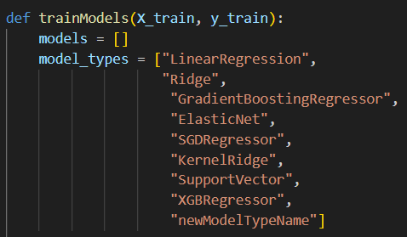

What do the RMSE values mean?
The RMSE measures the square root of the average of the squared differences between predicted and actual values. Basically, the lower the score, the more accurate the model.

